Дата: 03.02.2023 Клас: 7-Б

Предмет: Англійська мова

Тема: Спортивні досягнення українських спортсменів.

Мета: формувати навички вживання нових лексичних одиниць з теми «Спорт. Спортивні ігри. Види спорту»; удосконалювати навички аудіювання й усного мовлення з опорою на лексико-граматичні структури; розвивати мовну здогадку; виховувати доброзичливе ставлення до співрозмовника

Вчитель: Глуговська Л.Г.

**Хід уроку**

***1.Greeting***

Good afternoon, dear children! I’m glad to see you. Are you ready to start our lesson? Let’s start.

***2. Warming up***

Answer the questions.

1. What do you do to keep fit?

2. Are there any fitness clubs in your town?

3. Have you ever gone to a fitness club?

4. Do you do any sports?

5. What sport is it?

6. How often do you go in for sports and where?

7. What sport is popular in your family?

8. Do you take part in any competitions?

***3. Reading***

*Read to the text about water polo rules and complete the sentences in ex. 5, p. 102.*

Water polo originated in England and Scotland was one of the original team sports at the first modern Olympic Games in 1900 with Great Britain winning the first four men’s Olympic gold medals in 1900, 1908,1912 and 1920.

The sport combines speed and strength as well as teamwork and a high level of fitness — one outfield player can cover up to two miles in one game alone.

The playing area is ЗО X 20 meters with a minimum of 2 meters of depth.

The game is played in four quarters, each quarter being eight minutes in length with two-minute intervals between quarters. The home team usually wear white caps and the visiting team wear coloured (traditionally blue). Goalkeepers must wear red caps to make them easily identifiable to the referees. Caps are numbered from 1 to 13 with goalkeepers wearing 1 and 13. Only seven players per team are allowed in the water at one time.

Players cannot touch the bottom or sides of the pool. Except for the goalkeeper, players may handle the bright yellow colour ball with only one hand.

Penalty shots are taken from 5 meters directly in front of the goal. There are ordinary fouls and major fouls. Major fouls result is a temporary 20-second removing.

***4. Speaking***

***Ex.5 page 102***

*Доповніть правила, прочитавши текст.*

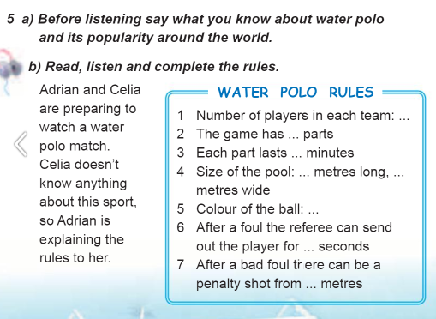

***5.Writing***

***Friday, the third of February  
Homework***

***Ex. 2 page 107***

*Напишіть твір про свого улюбленого спортсмена, використовуйте питання. Обсяг 6-10 речень.*

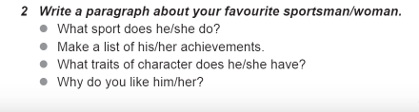

***6. Homework***

Домашнє завдання:

1. Опрацювати конспект, вивчити правило;

2. Ex. 2 page 107 (письмово).

**Надіслати виконане завдання у Вайбер/телеграм (0964124047) – Людмила Григорівна або на Human**